Lecture # 22:

Objective:

* FILE STREAMING

o Use of File Stream and Stream reader , Stream Writer

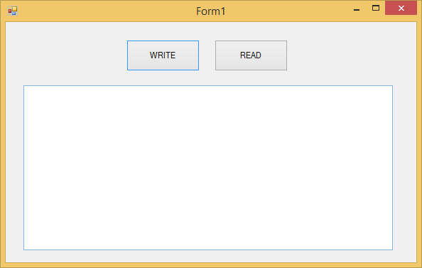

using System;

using System.Collections.Generic; using System.ComponentModel; using System.Data;

using System.Drawing; using System.Linq; using System.Text;

using System.Threading.Tasks; using System.Windows.Forms; using System.IO;

namespace WindowsFormsApplication1

{

public partial class Form1 : Form

{

public Form1()

{

InitializeComponent();

}

private void button1_Click(object sender, EventArgs e)

{

FileStream f = new FileStream("f:\\abc.txt", FileMode.OpenOrCreate, FileAccess.Read);

StreamReader sr = new StreamReader(f); textBox1.Text = sr.ReadToEnd(); sr.Close();

f.Close();

}

private void button2_Click(object sender, EventArgs e)

{

FileStream f = new FileStream("f:\\abc.txt", FileMode.Append, FileAccess.Write);

StreamWriter sw = new StreamWriter(f); sw.Write(textBox1.Text);

sw.Close();

}

}

}